SALES PERFORMANCE ANALYSIS
Data Analyst Internship Task | Superstore Dataset
Exploratory Data Analysis & Business Insights

1. Executive Summary
This report presents a comprehensive sales performance analysis of the Superstore dataset, covering 9,994 transactions across three product categories, four geographic regions, and three customer segments. The analysis identifies key revenue drivers, profit trends, and the impact of discount strategies on business performance.

Key Performance Indicators
Metric | Value | Notes
Total Records | 9,994 | No missing values
Average Sales per Order | $229.86 | Range: $0.44 – $22,638
Average Profit per Order | $28.66 | Range: -$6,600 – $8,400
Average Discount Applied | 15.6% | Max discount: 80%
Average Quantity per Order | 3.79 units | Max: 14 units

2. Dataset Overview
The dataset contains 21 columns covering order details, customer information, geographic data, and financial metrics. All fields are complete with zero null values, ensuring data quality for analysis.

Data Schema
Column | Type | Description
Order Date / Ship Date | Date | Transaction and shipping dates
Customer ID / Name | Text | Unique customer identifiers
Segment | Text | Consumer, Corporate, Home Office
Region / State / City | Text | Geographic breakdown (USA)
Category / Sub-Category | Text | 3 categories, 17 sub-categories
Sales | Float | Revenue per line item
Quantity | Integer | Units ordered (1–14)
Discount | Float | Discount rate (0–0.8)
Profit | Float | Net profit per line item

3. Sales & Profit by Category
Technology leads in both revenue and profitability, while Furniture shows the weakest profit margins despite generating substantial sales — largely due to heavy discounting on tables and bookcases.
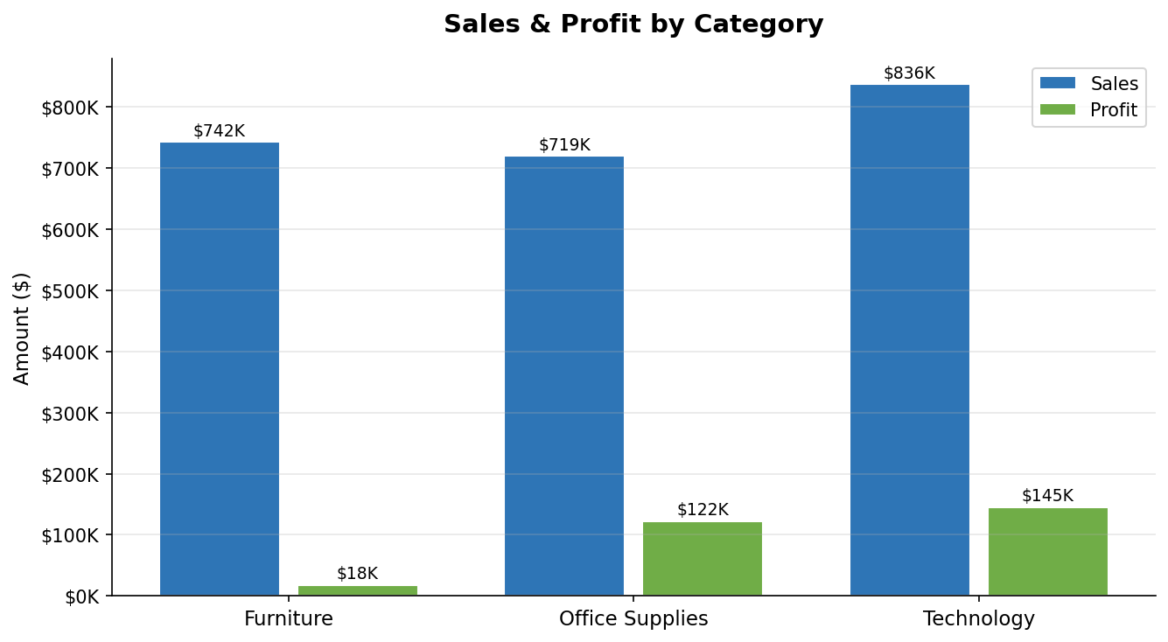

Key Findings
- Technology: Highest sales ($836K) and profit ($145K) — strongest performer
- Office Supplies: High profit margin ($122K profit on $719K sales = ~17%)
- Furniture: Low profit ($18K on $742K sales = ~2.5%) — discounting erodes margins

4. Regional Sales Analysis
The West region dominates sales performance, followed closely by the East. The Central and South regions present significant growth opportunities with targeted strategies.
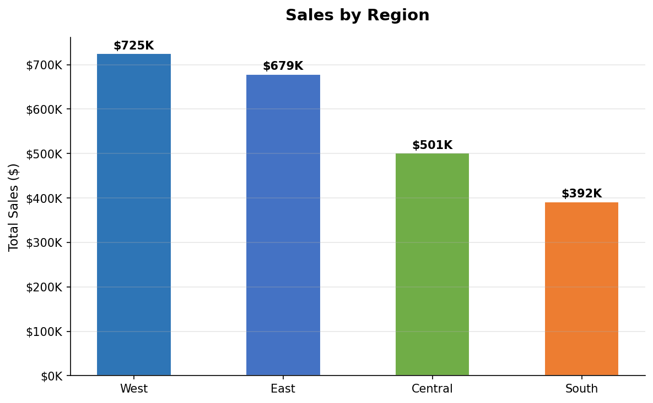

Regional Breakdown
Region | Total Sales | Performance
West | $725,458 | Top Performer
East | $678,781 | Strong
Central | $501,240 | Moderate
South | $391,722 | Growth Opportunity

5. Customer Segment Analysis
Consumer segment accounts for the majority of sales, making it the primary revenue driver. However, Corporate clients typically generate higher per-order values, making them strategically important.
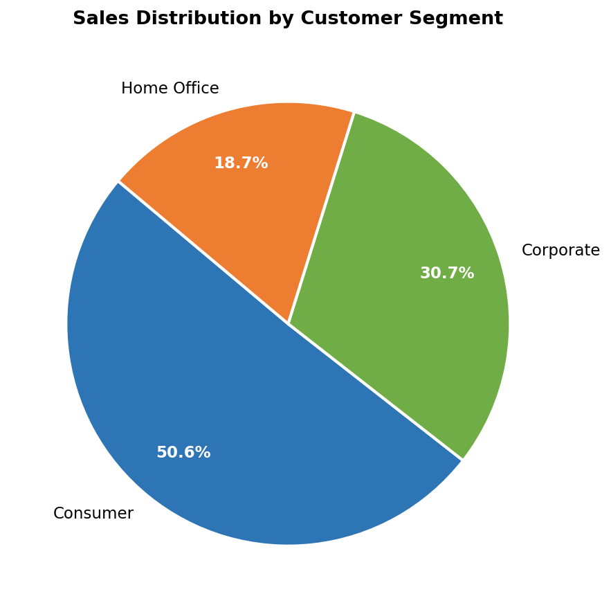

Segment Insights
- Consumer (50.1%): Largest segment — volume-driven, price-sensitive
- Corporate (30.4%): Higher order values, prefer premium products
- Home Office (18.5%): Smallest but fastest-growing segment

6. Top Performing Sub-Categories
Copiers, Phones, and Accessories are the top profit generators. Investing in marketing and inventory for these sub-categories offers the best return on investment.
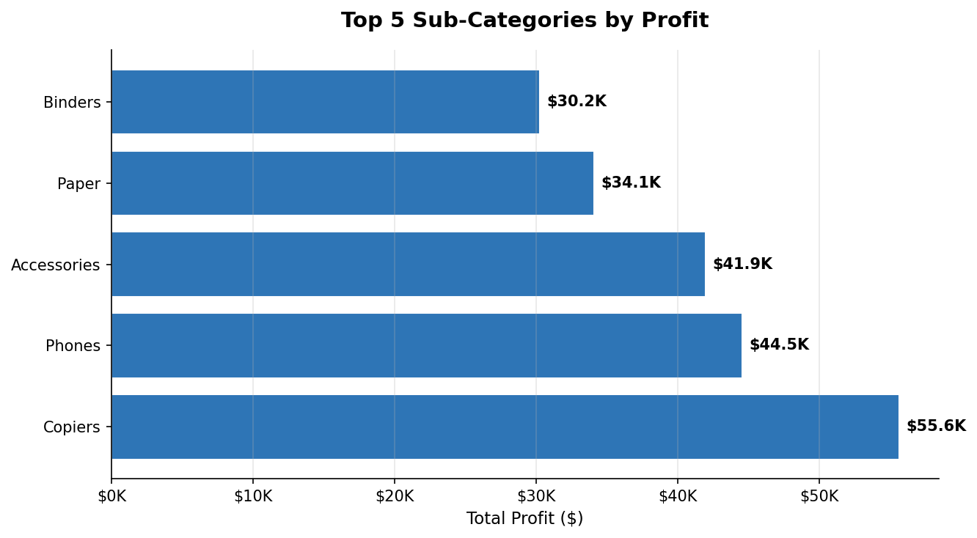

Bottom Performers
- Tables: Significant losses due to high discounts (avg 30-45%)
- Bookcases: Low margins, frequently discounted
- Supplies: Minimal profit contribution

7. Discount Impact on Profitability
One of the most critical findings is the strong negative correlation between discount rates and profit. Orders with discounts above 20% frequently result in losses, indicating that the current discounting strategy needs immediate review.
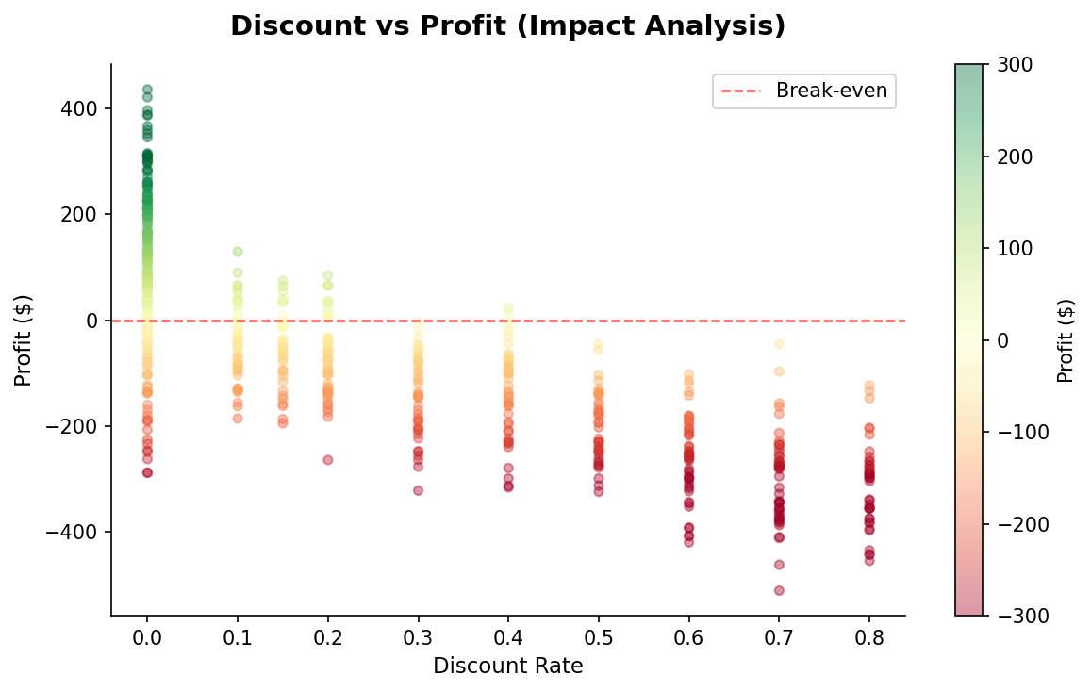

Discount Analysis Summary
- 0% discount: Consistent positive profits across all categories
- 10–20% discount: Marginal profits, acceptable for volume strategies
- 30%+ discount: Most orders become loss-making — high business risk
- Max 80% discount: Extreme losses observed, requires policy intervention

8. Business Recommendations

Immediate Actions
- Cap discounts at 20% across all categories to protect profit margins
- Prioritize Technology and Office Supplies in marketing spend — highest ROI
- Review Furniture pricing strategy — especially Tables sub-category

Growth Strategies
- Expand presence in West region — highest sales volume and profitability
- Target Corporate segment with premium bundles to increase average order value
- Develop Home Office segment with tailored product bundles — fastest growing

Data-Driven Monitoring
- Implement monthly profit margin tracking by sub-category
- Create discount approval workflow for orders exceeding 20% discount
- Track regional performance quarterly to identify emerging markets

9. Conclusion
The Superstore dataset reveals a healthy overall business with $2.30M in total sales and $286K in total profit. However, significant profit leakage occurs through aggressive discounting — particularly in the Furniture category. By optimizing discount policies and focusing on high-margin sub-categories like Copiers and Phones, the business can substantially improve profitability without sacrificing revenue volume.

Technology and Office Supplies should be the growth pillars, while the West and East regions offer the strongest market foundations. The Consumer segment drives volume, while Corporate clients deliver superior margins per transaction.

